**11th Dec FSDA2.0 (live assignment work)**

**Creating Table**

Create Table SALES1 (

Order_ID VARCHAR (60),

Order_Date VARCHAR (60),

Ship_Date VARCHAR (60),

Ship_Mode VARCHAR (60),

Customer_Name VARCHAR (60),

Segment VARCHAR (60),

State VARCHAR (60),

Country VARCHAR (60),

Market VARCHAR (60),

Region VARCHAR (60),

Product_ID VARCHAR (60),

Category VARCHAR (60),

Sub_Category VARCHAR (60),

Product_Name string,

sales number(10,0),

Quantity int,

Discount float,

Profit float,

Shipping_Cost float,

Order_Priority VARCHAR (60),

Year int

);

**Answers for the Questions**

1 . SET PRIMARY KEY.

ALTER TABLE sales1 ADD PRIMARY KEY (Order_ID)

2. CHECK THE ORDER DATE AND SHIP DATE TYPE AND THINK IN WHICH DATA TYPE YOU HAVE TO CHANGE.

Order date and ship date was cleaned and set to YYYY-MM-DD in Excel

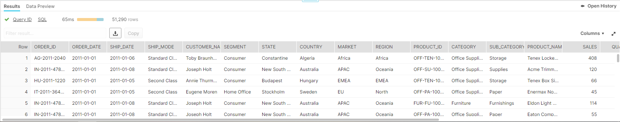

3. EXTACT THE LAST NUMBER AFTER THE - AND CREATE OTHER COLUMN AND UPDATE IT.

The last digits after ‘-‘ was done on Excel by using **Right(cell, SEARCH("char", cell)-1) formula** and cleaning remaining ‘- ‘.

4. FLAG ,IF DISCOUNT IS GREATER THAN 0 THEN YES ELSE FALSE AND PUT IT IN NEW COLUMN FRO EVERY ORDER ID.

select *,

CASE when 'Discount' > '0' then'Yes'

else 'False'

end as IF_DISCOUNTED

from sales1;

5. FIND OUT THE FINAL PROFIT AND PUT IT IN COLUMN FOR EVERY ORDER ID. **( In doubt clearing class you have mentioned to ignore this question)**

select *,

CASE when 'PROFIT' > '0' then 'PROFIT'

when 'PROFIT' < '0 ' then 'LOSS'

else 'NO PROFIT OR LOSS'

end as SALE_STATUS

from sales1;

6. FIND OUT HOW MUCH DAYS TAKEN FOR EACH ORDER TO PROCESS FOR THE SHIPMENT FOR EVERY ORDER ID.

SELECT DATEDIFF (day,Order_Date, Ship_Date)

from sales1;

7 . FLAG THE PROCESS DAY AS BY RATING IF IT TAKES LESS OR EQUAL 3 DAYS MAKE 5,LESS OR EQUAL THAN 6 DAYS BUT MORE THAN 3 MAKE 4,LESS THAN 10 BUT MORE THAN 6 MAKE 3,MORE THAN 10 MAKE IT 2 FOR EVERY ORDER ID.

select *,

case when DATEDIFF (day,Order_Date, Ship_Date) <= 3 then 5

when DATEDIFF (day,Order_Date, Ship_Date) <= 6 and DATEDIFF (day,Order_Date, Ship_Date) > 3 then 4

when DATEDIFF (day,Order_Date, Ship_Date) > 10 and DATEDIFF (day,Order_Date, Ship_Date) > 3 then 3

when DATEDIFF (day,Order_Date, Ship_Date) > 10 and DATEDIFF (day,Order_Date, Ship_Date) then 2

else 2

end as Rating

from sales1;